## Fast Forward Merge:-

## A fast-forward merge can occur when there is a linear path from the current branch tip to the target branch. Instead of “actually” merging the branches, all Git has to do to integrate the histories is move (i.e., “fast forward”) the current branch tip up to the target branch tip. This effectively combines the histories, since all of the commits reachable from the target branch are now available through the current one. For example, a fast forward merge of some-feature into main would look something like the following:

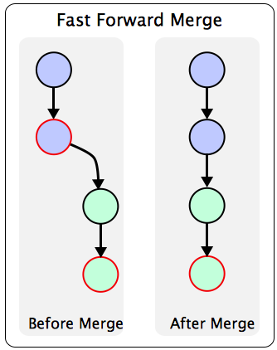

**created direcotory fastforwardmerge**

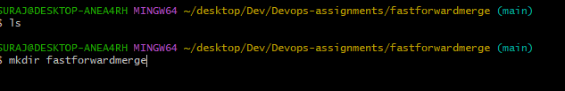

**created file1.txt,file2.txt in main branch.**

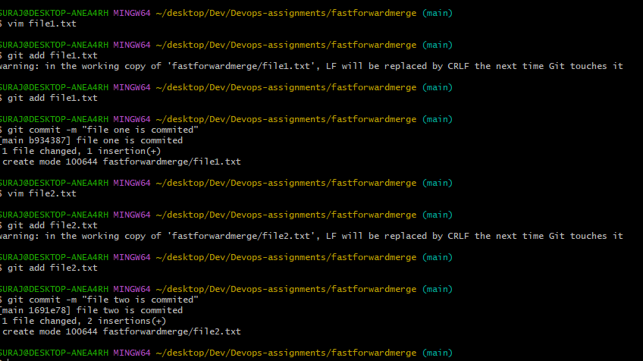

**Created test branch.**

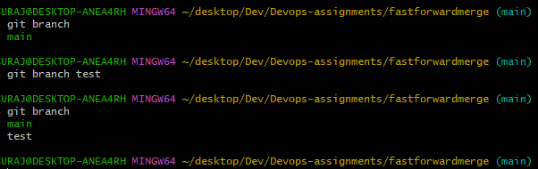

**switch to test branch using gitcheckout command.**

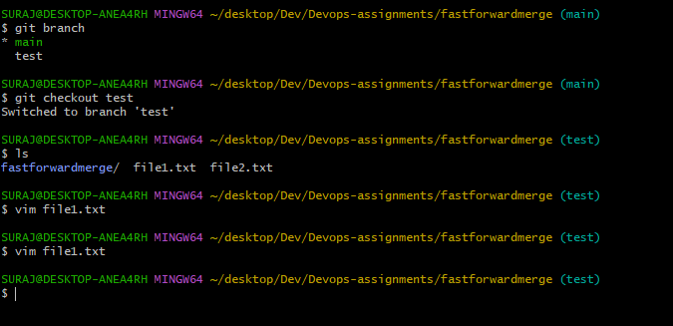

**Edited file1.txt from test branch.**



**Edited file2.txt from test branch.**





**Committed two files from test branch.**

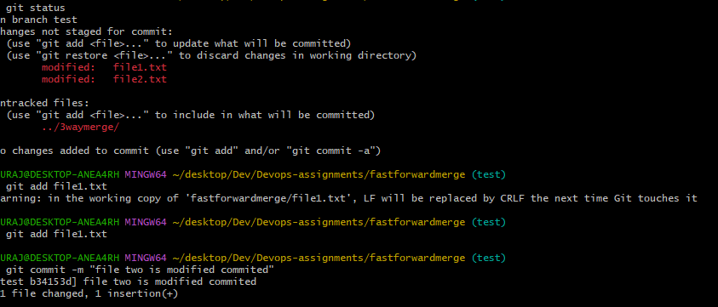

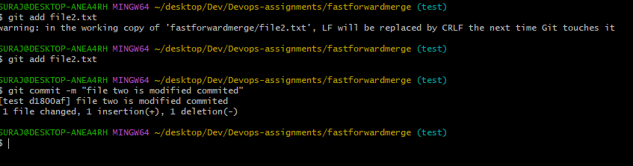

**Using git log – graph –pretty=oneline command display the all committed from test branch.**

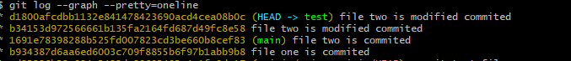

**Switch to main branch and merge test branch committed files into main branch.**

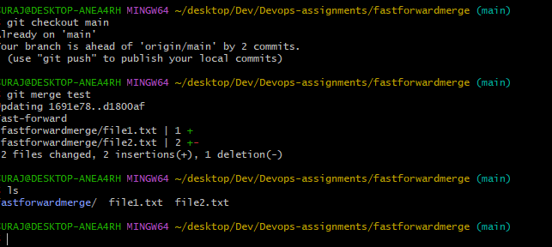**Output:**

